**SHOW DATABASE;**



**SHOW TABLES;**

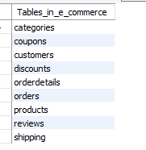

**-- Q1 SHOW ALL THE CATEGORY OF ITEMS THIS E-COMMERCE BUSINESS DEAL WITH?**

**SELECT**

**CATEGORYNAME**

**FROM**

**CATEGORIES;**

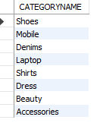

**-- ALL DISTINCT PRODUCTS:-**

**SELECT DISTINCT**

**NAME AS PRODUCT_NAME**

**FROM**

**PRODUCTS;**

**-- Q2 SHOW HOW OLD THIS BUSINESS IS TO KNOW THAT GET THE FIRST ORDER DATE FROM THE TABLES?**

**SELECT**

**ORDERDATE**

**FROM**

**ORDERS**

**ORDER BY ORDERDATE**

**LIMIT 1;**



**-- Q3 SHOW TOTAL PROFIT GAIN FROM ALL categories.**

**SELECT**

**P1.CATEGORYID, sum(P1.PRICE * DT.QUANTITY) AS TOTAL_REVENUE**

**FROM**

**PRODUCTS P1**

**JOIN**

**ORDERDETAILS DT ON P1.PRODUCTID = DT.PRODUCTID**

**GROUP BY CATEGORYID**

**ORDER BY TOTAL_REVENUE DESC;**

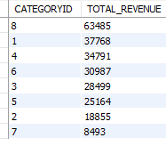

**-- Q4 SHOW TOTAL PROFIT GAIN FROM ALL SALES WITH THE PRODUCT NAME**

**SELECT**

**P1.NAME, P1.CATEGORYID,**

**sum(P1.PRICE * DT.QUANTITY) AS TOTAL_REVENUE**

**FROM**

**PRODUCTS P1**

**JOIN**

**ORDERDETAILS DT ON P1.PRODUCTID = DT.PRODUCTID**

**GROUP BY P1.CATEGORYID;**

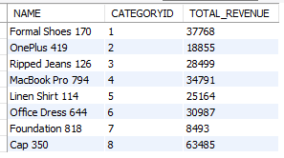

**-- Q5 CUSTOMERS WHO GAVE MORE THAN 1 REVIEW ?**

**SELECT CUSTOMERID, COUNT(REVIEWID) AS TOTAL_REVIEWS**

**FROM REVIEWS**

**GROUP BY CUSTOMERID**

**HAVING COUNT(REVIEWID) > 1;**

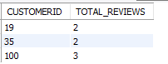

**-- Q6 CHECK THE RATING AND FIND IF MOST OF THE FEEDBACKS WERE POSITIVE?**

**SELECT**

**SUM(RATING) as TOTAL_POSITIVE**

**FROM**

**REVIEWS**

**WHERE**

**RATING >= 4;**



**-- Q6 CHECK THE RATING AND FIND IF MOST OF THE FEEDBACKS WERE NEGATIVE?**

**SELECT**

**SUM(RATING) AS TOTAL_NEGATIVE FROM**

**REVIEWS**

**WHERE**

**RATING < 4;**



**-- Q 7 WHAT IS THE MOST ORDERED ITEM FROM THE LIST OF CATEGORIES?**

**SELECT**

**P1.NAME,**

**P1.CATEGORYID,**

**SUM(OD.QUANTITY) AS MOST_ORDERED_QTY**

**FROM**

**PRODUCTS P1**

**JOIN**

**ORDERDETAILS OD ON P1.PRODUCTID = OD.PRODUCTID**

**GROUP BY**

**P1.PRODUCTID, P1.NAME, P1.CATEGORYID**

**ORDER BY**

**MOST_ORDERED_QTY DESC;**

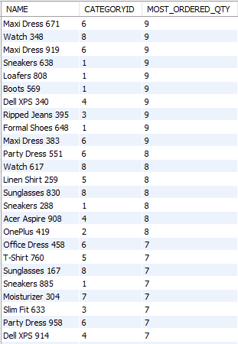

**-- Q8. Show the order details by 5 most expensive products and their revenue generated from orders?**

**SELECT**

**P1.PRODUCTID,**

**P1.NAME,**

**P1.PRICE,**

**P1.STOCKQUANTITY,**

**SUM(OD.QUANTITY * P1.PRICE) AS TOTAL_REVENUE**

**FROM**

**PRODUCTS P1**

**JOIN**

**ORDERDETAILS OD ON P1.PRODUCTID = OD.PRODUCTID**

**GROUP BY**

**P1.PRODUCTID, P1.NAME, P1.PRICE, P1.STOCKQUANTITY**

**ORDER BY**

**SUM(OD.QUANTITY * P1.PRICE) DESC**

**LIMIT 5;**

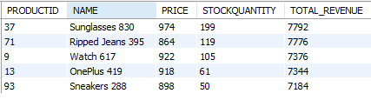

**-- Q9 .Names the customers id who have not ordered any product from us?**

**SELECT**

**\*FROM**

**customers**

**WHERE customerid not in(select distinct customerid from orders);**



**-- Q10 .Name the category with the highest revenue?**

**SELECT**

**C1.CATEGORYNAME,**

**P1.CATEGORYID,**

**Sum(P1.PRICE * OD.QUANTITY - DA.DISCOUNTAMOUNT) AS TOTAL_REVENUE**

**FROM**

**PRODUCTS P1**

**JOIN**

**orderdetails OD**

**JOIN**

**DISCOUNTS DA**

**JOIN**

**CATEGORIES C1 ON P1.PRODUCTID = DA.PRODUCTID**

**AND P1.PRODUCTID = OD.PRODUCTID**

**GROUP BY P1.CATEGORYID**

**ORDER BY TOTAL_REVENUE DESC**

**LIMIT 1;**



**-- 11 .Show the category with the least orders**

**SELECT**

**C1.CATEGORYNAME,**

**sum(P1.PRICE * OD.QUANTITY - DA.DISCOUNTAMOUNT) AS TOTAL,**

**P1.CATEGORYID**

**FROM**

**PRODUCTS P1**

**JOIN**

**orderdetails OD**

**JOIN**

**DISCOUNTS DA**

**JOIN**

**CATEGORIES C1 ON P1.PRODUCTID = DA.PRODUCTID**

**AND P1.PRODUCTID = OD.PRODUCTID**

**GROUP BY P1.CATEGORYID**

**ORDER BY TOTAL**

**LIMIT 1;**



**-- 12 How many days did each order take to be delivered?**

**SELECT**

**ORDERID, DATEDIFF(DELIVERYDATE, SHIPDATE) DELIVERY_DAYS**

**FROM**

**SHIPPING;**

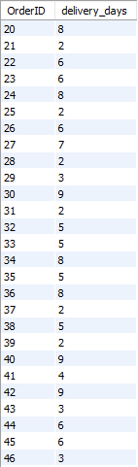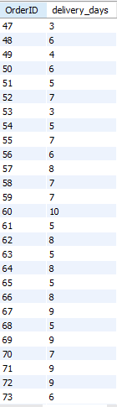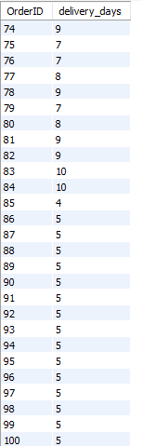

**-- Q13 find the sum of all orders ?**

**SELECT COUNT(DISTINCT ORDERID) AS TOTAL_ORDERS FROM ORDERS;**



**--Q14 HIGEST SALES IN WEEKEND OR WEEKDAYS?**

**SELECT**

**COUNT(ORDERID) AS TOTAL,**

**ORDERDATE,**

**IF(DAYOFWEEK(ORDERDATE) IN (1 , 7),**

**'WEEKEND',**

**'WEEKDAY') AS DAY_TYPE**

**FROM**

**ORDERS**

**GROUP BY DAY_TYPE;**

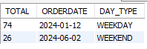

**--Q16 What is the total number of products, total price value, and total stock available in the PRODUCTS table?**

**SELECT**

**COUNT(NAME) AS 'TOTAL PRODUCTS',**

**SUM(PRICE) AS 'TOTAL AMOUNT',**

**SUM(STOCKQUANTITY) AS 'TOTAL_STOCK'**

**FROM**

**PRODUCTS;**



**-- Q17 FIND THE CATEGORY NAMES AND ITS TOTAL PRICES.**

**SELECT**

**C1.CATEGORYNAME, SUM(P1.PRICE) AS SUM_OF_PRICE**

**FROM**

**PRODUCTS P1**

**INNER JOIN**

**CATEGORIES C1 ON C1.CATEGORYID = P1.CATEGORYID**

**GROUP BY CATEGORYNAME;**

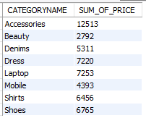

**-- Q18 FIND THE REVENUE OF DRESS CATEGORY ITEM WISE (CATEGORY=6)?**

**SELECT DISTINCT**

**P1.CATEGORYID,**

**P1.NAME,**

**P1.PRICE * DT.QUANTITY AS TOTAL_REVENUE**

**FROM**

**PRODUCTS P1**

**JOIN**

**ORDERDETAILS DT ON P1.PRODUCTID = DT.PRODUCTID**

**WHERE**

**CATEGORYID = 6**

**ORDER BY TOTAL_REVENUE DESC;**

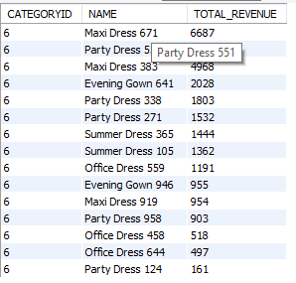

**-- Q19 FIND THE TOTAL REVENUE FROM ACESSESSORY CATEGORY?**

**SELECT DISTINCT**

**P1.CATEGORYID,**

**P1.NAME,**

**P1.PRICE * DT.QUANTITY AS TOTAL_REVENUE**

**FROM**

**PRODUCTS P1**

**JOIN**

**ORDERDETAILS DT ON P1.PRODUCTID = DT.PRODUCTID**

**WHERE**

**CATEGORYID = 8**

**ORDER BY TOTAL_REVENUE DESC;**

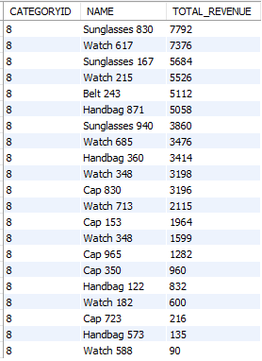

**-- -- Q20 return the no of product names and category id with the count of product ids?**

**SELECT**

**categoryid, name, COUNT(PRODUCTID) AS total_pid**

**FROM**

**PRODUCTS**

**GROUP BY categoryid**

**ORDER BY total_pid;**

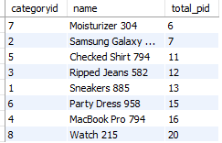

**-- Q21 find the minimum price, max price and avg price value in products?**

**SELECT**

**NAME, MAX(PRICE)**

**FROM**

**PRODUCTS;**

**SELECT**

**NAME, MIN(PRICE)**

**FROM**

**PRODUCTS;**

**SELECT**

**NAME, AVG(PRICE)**

**FROM**

**PRODUCTS;**



**-- Q22 RETRIEVE THE DATA WHERE THERE IS NAME AND TOTAL STOCKQUANTITY OF CATEGORY ID 8 WHICH IS ACCESSORIES.?**

**SELECT**

**NAME, SUM(STOCKQUANTITY) AS TOTAL_STOCK**

**FROM**

**PRODUCTS**

**WHERE**

**CATEGORYID = 8**

**ORDER BY TOTAL_STOCK**

**LIMIT 5;**



**-- Q23 NAME THE CATEGORY WITH CATEGORYID AND HIGHEST PRICE?**

**SELECT**

**C1.CATEGORYNAME, C1.CATEGORYID, PRICE**

**FROM**

**PRODUCTS P1**

**JOIN**

**CATEGORIES C1 ON C1.CATEGORYID = P1.CATEGORYID**

**WHERE**

**P1.PRICE = (SELECT**

**MAX(PRICE) AS MAX_PRICE**

**FROM**

**PRODUCTS);**



**-- Q24 FIND THE ITEM NAME AND CATEGORY NAME WITH TOTAL PRICE.**

**SELECT**

**P1.NAME, C1.CATEGORYNAME, SUM(P1.PRICE) AS TOTAL_PRICE**

**FROM**

**PRODUCTS P1**

**JOIN**

**CATEGORIES C1 ON C1.CATEGORYID = P1.CATEGORYID**

**GROUP BY C1.CATEGORYNAME;-- GROUP BY C1.CATEGORYNAME;**

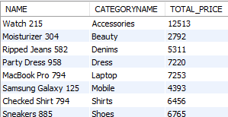

**-- Q25 Find out customer names, and total count of orders ?**

**SELECT**

**CUST1.NAME, COUNT(O1.ORDERID) AS TOTAL_COUNT**

**FROM**

**CUSTOMERS CUST1**

**JOIN**

**PRODUCTS P1**

**JOIN**

**ORDERS O1 ON CUST1.CUSTOMERID = O1.CUSTOMERID**

**GROUP BY CUST1.NAME;**

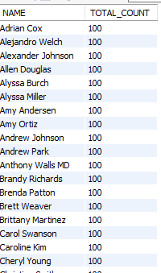

**-- Q26 FOR CATEGORY NAME AND TOTAL OF PRICE FOR SHOES ?**

**SELECT**

**C1.CATEGORYNAME, SUM(P1.PRICE) AS TOTAL_AMOUNT**

**FROM**

**PRODUCTS P1**

**JOIN**

**CATEGORIES C1 ON C1.CATEGORYID = P1.CATEGORYID;**



**-- Q27 NAME, TOTAL QUANTITY WITH THE PRODUCTS.**

**SELECT**

**P1.NAME, SUM(OD.QUANTITY) AS TOTAL_QUANTITY**

**FROM**

**ORDERDETAILS OD**

**JOIN**

**PRODUCTS P1 ON P1.PRODUCTID = OD.PRODUCTID**

**GROUP BY P1.NAME;**

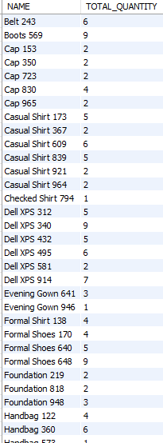

**-- Q28 SHOW CATEGORYID, REVIEWID,CUSTID, PRODUCTID, RATING COMMENTS WHERE WE GOT RATINGS (4,5) WITH COMMENTS?**

**SELECT**

**R1.REVIEWID,**

**R1.CUSTOMERID,**

**P1.PRODUCTID,**

**P1.CATEGORYID,**

**R1.RATING,**

**R1.COMMENTS**

**FROM**

**REVIEWS R1**

**LEFT JOIN**

**PRODUCTS P1 ON R1.PRODUCTID = P1.PRODUCTID**

**WHERE**

**R1.RATING BETWEEN 4 AND 5**

**ORDER BY RATING DESC;**

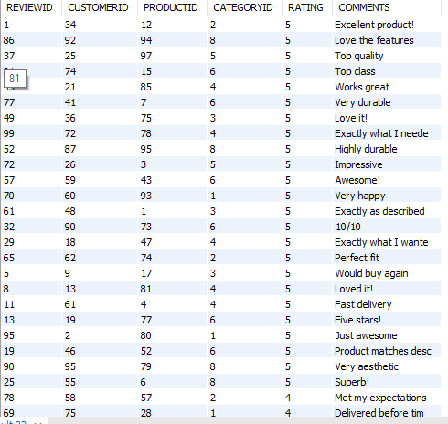

**-- Q29 FIND CUSTOMER NAME WITH THE PRODUCT THEY PURCHASED?**

**SELECT**

**CUST1.NAME AS CUSTOMER_NAME, P1.NAME AS PRODUCT_NAME, COUNT(P1.PRODUCTID) AS TOTAL_ORDERS**

**FROM**

**CUSTOMERS CUST1**

**JOIN**

**ORDERS O1 ON CUST1.CUSTOMERID = O1.CUSTOMERID**

**JOIN**

**ORDERDETAILS OD ON O1.ORDERID = OD.ORDERID**

**JOIN**

**PRODUCTS P1 ON OD.PRODUCTID = P1.PRODUCTID**

**WHERE CUST1.NAME = 'Susan Robbins' GROUP BY P1.NAME, CUST1.NAME;**



**-- Q30 Names the customers id who ordered at least?**

**SELECT**

**CUSTOMERID, COUNT(ORDERID) AS tot_orders**

**FROM**

**orders**

**WHERE**

**CUSTOMERID IS NOT NULL**

**GROUP BY CUSTOMERID;**

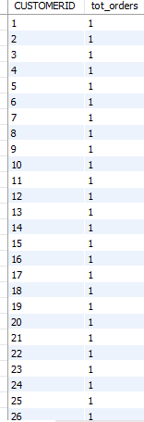

**-- Q 31 TOTAL REMAINING STOCK ?**

**SELECT**

**SUM(P1.STOCKQUANTITY) - SUM(OD.QUANTITY) AS REMAINING_STOCK**

**FROM**

**PRODUCTS P1**

**JOIN**

**ORDERDETAILS OD ON P1.PRODUCTID = OD.PRODUCTID;**



**-- Q32 TOTAL REVENUE FOR CATEGORY ID 4 WHICH IS LAPTOP?**

**SELECT DISTINCT**

**P1.CATEGORYID,**

**P1.NAME,**

**SUM(P1.PRICE) * SUM(DT.QUANTITY) - SUM(D.DISCOUNTAMOUNT) AS TOTAL_REVENUE**

**FROM**

**PRODUCTS P1**

**JOIN**

**ORDERDETAILS DT**

**JOIN**

**DISCOUNTS D ON P1.PRODUCTID = DT.PRODUCTID = D.PRODUCTID**

**WHERE**

**CATEGORYID = 4;**



**-- Q33 FOR CATEGORY 1 WHAT IS THE TOTAL REVENUE?**

**SELECT DISTINCT**

**P1.CATEGORYID, C1.CATEGORYNAME,**

**P1.NAME,**

**SUM(P1.PRICE) * SUM(DT.QUANTITY) - SUM(D.DISCOUNTAMOUNT) AS TOTAL_REVENUE**

**FROM**

**PRODUCTS P1**

**JOIN**

**ORDERDETAILS DT**

**JOIN**

**DISCOUNTS D**

**JOIN**

**CATEGORIES C1 ON P1.PRODUCTID = DT.PRODUCTID AND P1.CATEGORYID=C1.CATEGORYID**

**WHERE**

**C1.CATEGORYID = 1;**



**-- REVENUE FOR MOBILE**

**SELECT DISTINCT**

**P1.CATEGORYID,**

**P1.NAME,**

**SUM(P1.PRICE) * SUM(DT.QUANTITY) - SUM(D.DISCOUNTAMOUNT) AS TOTAL_REVENUE**

**FROM**

**PRODUCTS P1**

**JOIN**

**ORDERDETAILS DT**

**JOIN**

**DISCOUNTS D ON P1.PRODUCTID = DT.PRODUCTID = D.PRODUCTID**

**WHERE**

**CATEGORYID = 2;**



**-- FOR JEANS REVENUE**

**SELECT DISTINCT**

**P1.CATEGORYID,**

**P1.NAME,**

**SUM(P1.PRICE) * SUM(DT.QUANTITY) - SUM(D.DISCOUNTAMOUNT) AS TOTAL_REVENUE**

**FROM**

**PRODUCTS P1**

**JOIN**

**ORDERDETAILS DT**

**JOIN**

**DISCOUNTS D ON P1.PRODUCTID = DT.PRODUCTID = D.PRODUCTID**

**WHERE**

**CATEGORYID = 3;**

**-- SHIRTS REVENUE**

**SELECT DISTINCT**

**P1.CATEGORYID,**

**P1.NAME,**

**SUM(P1.PRICE) * SUM(DT.QUANTITY) - SUM(D.DISCOUNTAMOUNT) AS TOTAL_REVENUE**

**FROM**

**PRODUCTS P1**

**JOIN**

**ORDERDETAILS DT**

**JOIN**

**DISCOUNTS D ON P1.PRODUCTID = DT.PRODUCTID = D.PRODUCTID**

**WHERE**

**CATEGORYID = 5;**

**-- FOR BEAUTY REVENUE**

**SELECT DISTINCT**

**P1.CATEGORYID,**

**P1.NAME,**

**SUM(P1.PRICE) * SUM(DT.QUANTITY) - SUM(D.DISCOUNTAMOUNT) AS TOTAL_REVENUE**

**FROM**

**PRODUCTS P1**

**JOIN**

**ORDERDETAILS DT**

**JOIN**

**DISCOUNTS D ON P1.PRODUCTID = DT.PRODUCTID = D.PRODUCTID**

**WHERE**

**CATEGORYID = 7;**

**-- Q33 COUNT THE TOTAL PRODUCT NAMES WITH THE DESIGNATED CATEGORIES?**

**SELECT**

**P1.NAME, COUNT(P1.NAME) AS TOT_COUNT, C1.CATEGORYNAME**

**FROM**

**PRODUCTS P1**

**JOIN**

**CATEGORIES C1 ON C1.CATEGORYID = P1.CATEGORYID**

**GROUP BY C1.CATEGORYNAME;**

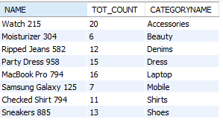

**-- Q34 NAME THE PRODUCTS WITH 5 RATINGS?**

**SELECT**

**P1.PRODUCTID, P1.NAME, RATING**

**FROM**

**REVIEWS R1**

**JOIN**

**PRODUCTS P1 ON P1.PRODUCTID = R1.PRODUCTID**

**WHERE**

**RATING = 5;**

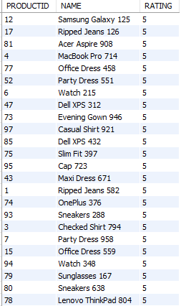

**-- Q35 NAME THE PRODUCTS WITH 1 RATINGS?**

**SELECT**

**P1.PRODUCTID, P1.NAME, RATING**

**FROM**

**REVIEWS R1**

**JOIN**

**PRODUCTS P1 ON P1.PRODUCTID = R1.PRODUCTID**

**WHERE**

**RATING = 1;**

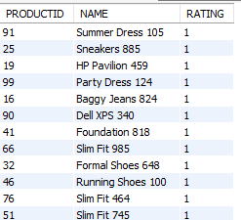

**-- Q36 COUNT OF COMMENTS WITH THE RATINGS 1 -5 IN TOTAL?**

**SELECT**

**RATING, COUNT(COMMENTS) AS TOTAL_COMMENTS**

**FROM**

**REVIEWS**

**GROUP BY RATING**

**ORDER BY RATING DESC;**

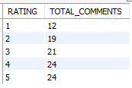

**-- Q 37 SUM OF TOTAL REMAINING ITEMS IN STOCK WITH PRODUCT NAME WISE?**

**SELECT**

**P1.NAME,**

**P1.CATEGORYID,**

**SUM(P1.STOCKQUANTITY) - SUM(OD.QUANTITY) AS REMAIN_STOCK**

**FROM**

**PRODUCTS P1**

**JOIN**

**ORDERDETAILS OD ON P1.PRODUCTID = OD.PRODUCTID**

**GROUP BY P1.NAME;**

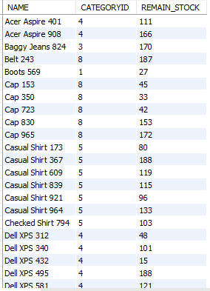

**-- Q38 SHOW CATEGORYID, REVIEWID,CUSTID, PRODUCTID, RATING COMMENTS WHERE WE GOT RATINGS (1,2,3) WITH COMMENTS?**

**SELECT**

**R1.REVIEWID,**

**R1.CUSTOMERID,**

**P1.PRODUCTID,**

**P1.CATEGORYID,**

**R1.RATING,**

**R1.COMMENTS**

**FROM**

**REVIEWS R1**

**LEFT JOIN**

**PRODUCTS P1 ON R1.PRODUCTID = P1.PRODUCTID**

**WHERE**

**RATING BETWEEN 1 AND 3**

**ORDER BY RATING DESC;**

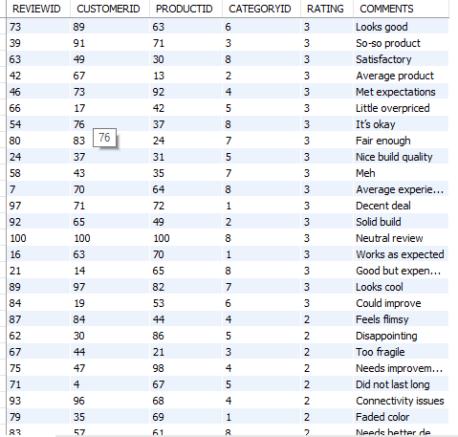

**-- Q39 NAME THE CATEGORIES WHERE WE GOT MAXIMUM COMMENTS**

**SELECT**

**P1.CATEGORYID, COUNT(R1.COMMENTS) AS TOT_COMMENTS**

**FROM**

**REVIEWS R1**

**JOIN**

**PRODUCTS P1 ON P1.PRODUCTID = R1.PRODUCTID**

**GROUP BY P1.CATEGORYID**

**ORDER BY TOT_COMMENTS DESC**

**LIMIT 1;**



**-- 40 NAME THE VALUE WITH THE HIGHEST PRODUCT VALUE?**

**SELECT**

**NAME, MAX(PRICE) AS HIGHEST_VALUE**

**FROM**

**PRODUCTS**

**GROUP BY NAME**

**ORDER BY HIGHEST_VALUE DESC**

**LIMIT 10;**

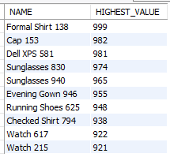

**-- Q41 GET THE YEAR WHEN THE FIRST ORDER WAS PLACED?**

**SELECT EXTRACT(YEAR FROM MIN(ORDERDATE)) AS FIRST_ORD_YEAR FROM ORDERS; --YEAR ITSELF**



**SELECT EXTRACT(YEAR FROM CURDATE()) - EXTRACT(YEAR FROM '2024-01-12') AS NO_OF_YEAR; -- NO OF YEARS**



**-- Q42 TOTAL PRODUCT SOLD?**

**SELECT SUM(OD.QUANTITY) AS TOTAL_SOLD**

**FROM PRODUCTS P1**

**JOIN ORDERDETAILS OD ON P1.PRODUCTID = OD.PRODUCTID;**



**-- Q43 HOW WAS THE SALES TREND SINCE BEGINNING TILL DATE (DATEWISE ASC)?**

**SELECT**

**O1.ORDERDATE,**

**SUM(P1.PRICE * OD.QUANTITY) AS TOTAL_SALES**

**FROM**

**ORDERS O1**

**JOIN**

**ORDERDETAILS OD ON O1.ORDERID = OD.ORDERID**

**JOIN PRODUCTS P1 ON OD.PRODUCTID=P1.PRODUCTID**

**WHERE O1.ORDERDATE BETWEEN '2024-01-06' AND '2024-12-27'**

**GROUP BY O1.ORDERDATE**

**ORDER BY O1.ORDERDATE;**

**Observation Summary:**

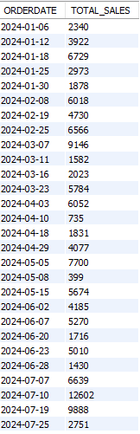 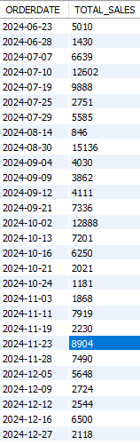

**-- Q44 NO OF DAYS THIS BUSINESS WORKED UNTIL LAST ORDER?**

**SELECT**

**DATEDIFF(CURDATE(), '2024-01-12') AS TOTAL_DAYS**

**FROM**

**ORDERS**

**GROUP BY CUSTOMERID**

**LIMIT 1;**



**-- Q45 FIND THE CATEGORY NAME WITH ITS AVG PRODUCT PRICE?**

**SELECT**

**C1.CATEGORYNAME, ROUND(AVG(P1.PRICE), 0) AS AVG_PRICE**

**FROM**

**PRODUCTS P1**

**JOIN**

**CATEGORIES C1 ON C1.CATEGORYID = P1.CATEGORYID**

**GROUP BY C1.CATEGORYNAME;**

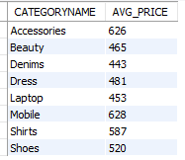

**-- Q46 FIND THE NAME, TOTAL PRICE WITH TOTAL GIVEN DISCOUNT FOR MacBook Pro 811 PRODUCT?**

**SELECT**

**P1.NAME,**

**SUM(P1.PRICE) AS TOTAL_QTY,**

**SUM(D1.DISCOUNTAMOUNT) TOT_DISCOUNT**

**FROM**

**PRODUCTS P1**

**JOIN**

**DISCOUNTS D1 ON D1.PRODUCTID = P1.PRODUCTID**

**WHERE**

**P1.NAME = 'MacBook Pro 811';**



**-- Q 47 FIND THE SALES IN FIRST 6MONTHS WITH THE CATEGORY ID, AMOUNT AND ORDER BY ORDERDATE ASCENDING?**

**SELECT**

**SUM(P1.PRICE * OD.QUANTITY - DA.DISCOUNTAMOUNT) AS TOTAL,**

**C1.CATEGORYNAME,**

**O1.ORDERDATE**

**FROM**

**PRODUCTS P1**

**JOIN**

**orderdetails OD**

**JOIN**

**DISCOUNTS DA**

**JOIN**

**ORDERS O1**

**JOIN**

**categories C1 ON P1.PRODUCTID = DA.PRODUCTID**

**AND P1.PRODUCTID = OD.PRODUCTID**

**AND O1.ORDERID = OD.ORDERID**

**AND C1.CATEGORYID = P1.CATEGORYID**

**GROUP BY C1.CATEGORYNAME**

**HAVING O1.ORDERDATE BETWEEN '2024-01-06' AND '2024-07-04'**

**ORDER BY O1.ORDERDATE;**

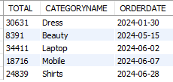

**-- Q 48 FIND THE SUM OF TOTAL FIRST 6MOHNTHS REVENUE**

**SELECT**

**SUM(P1.PRICE * OD.QUANTITY - DA.DISCOUNTAMOUNT) AS TOTAL,**

**C1.CATEGORYNAME, O1.ORDERDATE FROM**

**PRODUCTS P1 JOIN**

**orderdetails OD JOIN**

**DISCOUNTS DA JOIN**

**ORDERS O1 JOIN**

**categories C1 ON P1.PRODUCTID = DA.PRODUCTID**

**AND P1.PRODUCTID = OD.PRODUCTID**

**AND O1.ORDERID = OD.ORDERID**

**AND C1.CATEGORYID = P1.CATEGORYID**

**GROUP BY C1.CATEGORYNAME**

**HAVING O1.ORDERDATE BETWEEN '2024-01-06' AND '2024-07-04'**

**ORDER BY O1.ORDERDATE;**

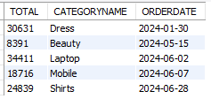

**--- Q49 - return the no. of product names and get the product ids and category ids.?**

**SELECT**

**categoryid, name, COUNT(PRODUCTID) AS total_pid**

**FROM**

**PRODUCTS**

**GROUP BY categoryid;**

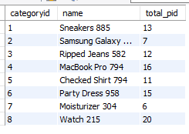

**-- -- Q50 Return the name, category id and sum of stock left ?**

**SELECT**

**P1.NAME,**

**P1.CATEGORYID,**

**SUM(P1.STOCKQUANTITY) - SUM(OD.QUANTITY) AS REMAIN_STOCK**

**FROM**

**PRODUCTS P1**

**JOIN**

**ORDERDETAILS OD ON P1.PRODUCTID = OD.PRODUCTID**

**GROUP BY P1.NAME order by Remain_stock desc;**

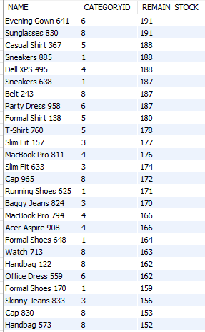

**-- -- Q51 Return the name, category id and sum of stock left ?**

**SELECT**

**DATE_FORMAT(O1.OrderDate, '%Y-%m') AS MONTH,**

**ROUND(SUM(P1.PRICE) * SUM(DT.QUANTITY) - SUM(D.DISCOUNTAMOUNT),0) AS TOTAL_REVENUE**

**FROM**

**PRODUCTS P1**

**JOIN**

**ORDERDETAILS DT JOIN DISCOUNTS D JOIN ORDERS O1 ON P1.PRODUCTID = DT.PRODUCTID**

**AND P1.PRODUCTID=D.PRODUCTID AND O1.ORDERID=DT.ORDERID GROUP BY MONTH**

**ORDER BY TOTAL_REVENUE desc;**

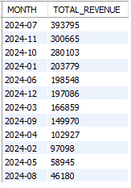

**Conclusion:**The business began its journey on '2024-01-06’ and has grown steadily since then, with weekdays showing stronger sales and revenue. Accessories (Category 8) have been the top-performing products, while Beauty (Category 7) saw the least traction. Customers generally responded positively, with most reviews rated 4 or 5 stars. Inventory insights helped highlight what's in demand and what's sitting on shelves. Sales hit a high in July 2024 with 393,795 units, but dipped in August to 46,180, possibly due to seasonal factors. Customer data also revealed loyal buyers as well as those yet to make a purchase—offering a chance to better target future campaigns.